Project Design Phase-II
Technology Stack (Architecture & Stack)

Date | 30 September 2026
Team ID | SWTID-2026-7743
Project Name | AI FAQ Assistant API
Maximum Marks | 4 Marks

Technical Architecture:
The Deliverable shall include the architectural diagram as below and the information as per the table1 & table 2
Technical Architecture – AI FAQ Assistant API
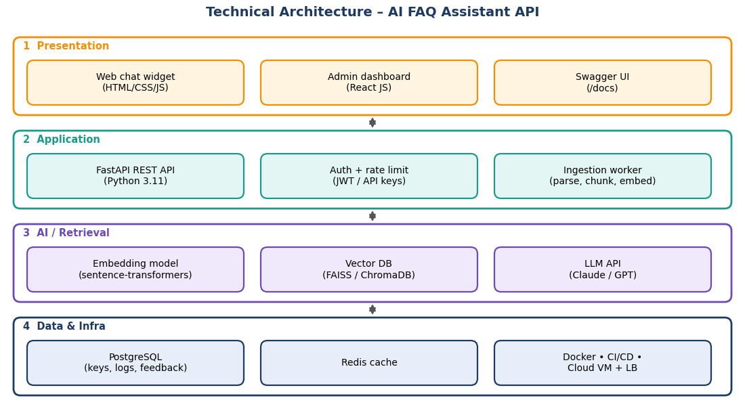
Table-1 : Components & Technologies:
S.No | Component | Description | Technology
 | User Interface | Embeddable web chat widget for end users and a React admin dashboard for FAQ upload, analytics and API keys | HTML, CSS, JavaScript, React JS
 | Application Logic-1 | REST API layer: routing, authentication, rate limiting and request validation | Python 3.11, FastAPI, Pydantic, Uvicorn
 | Application Logic-2 | Ingestion pipeline: parse CSV / JSON / PDF, clean text, split into chunks and create embeddings | pandas, PyPDF, sentence-transformers
 | Application Logic-3 | Query pipeline (RAG): embed question, retrieve top-k chunks, build grounded prompt, generate answer, compute confidence and attach source | Python, LLM API client, custom RAG logic
 | Database | Relational data (organisations, API keys, query logs, feedback) and vector data (FAQ embeddings) | PostgreSQL (SQLAlchemy); ChromaDB / FAISS
 | Cloud Database | Managed database service in the cloud for production | Amazon RDS for PostgreSQL (or equivalent)
 | File Storage | Uploaded FAQ documents (CSV / JSON / PDF) | Amazon S3 or local file system
 | External API-1 | Large language model used to write the final answer from the retrieved FAQ text | Anthropic Claude API / OpenAI API
 | External API-2 | Language detection and translation support for Tamil / Hindi questions | langdetect library, Google Cloud Translation API
 | Machine Learning Model | Sentence-embedding model for semantic search over FAQ chunks | sentence-transformers (all-MiniLM-L6-v2, multilingual-e5-small)
 | Infrastructure (Server / Cloud) | Application deployed as Docker containers.  Local Server Configuration: developer laptop, 8 GB RAM, Docker Compose.  Cloud Server Configuration: 2 vCPU / 4 GB RAM VM (scalable) behind a load balancer, CI/CD through GitHub Actions. | Docker, Docker Compose, AWS EC2 / Render, GitHub Actions

Table-2: Application Characteristics:
S.No | Characteristics | Description | Technology
 | Open-Source Frameworks | FastAPI, sentence-transformers, ChromaDB / FAISS, SQLAlchemy, Redis, React, Docker | Python and JavaScript open-source stack
 | Security Implementations | API-key and JWT authentication, hashed keys, HTTPS/TLS, rate limiting, input validation, per-organisation data isolation, secrets kept in environment variables | JWT, SHA-256 / bcrypt, TLS, OWASP Top 10 guidelines
 | Scalable Architecture | 3-tier design (UI, stateless API, data layer); containers can be replicated; ingestion runs asynchronously; vector store separated per organisation | Docker, FastAPI, background workers
 | Availability | Multiple replicas behind a load balancer, health-check endpoint, automatic container restart, managed database backups | Nginx / AWS Application Load Balancer, RDS backups
 | Performance | Redis cache for repeated questions, fast approximate nearest-neighbour search, async request handling; target of 3 seconds or less for 95% of queries | Redis, FAISS, Uvicorn (async)

References:
https://c4model.com/
https://developer.ibm.com/patterns/online-order-processing-system-during-pandemic/
https://www.ibm.com/cloud/architecture
https://aws.amazon.com/architecture
https://medium.com/the-internal-startup/how-to-draw-useful-technical-architecture-diagrams-2d20c9fda90d

